Public facing Angel Adoption:

Each Corps can enable or disable online adoption from their setup pages in AngelWeb

The Corps Code becomes the starting place

<http://www.pwhdev.net/AngelAdopt/welcome.html>

(to select a Corps Code)

or

<http://www.pwhdev.net/AngelAdopt/adoptbycode.asp?cc=LG>

(to select your Corps by code)

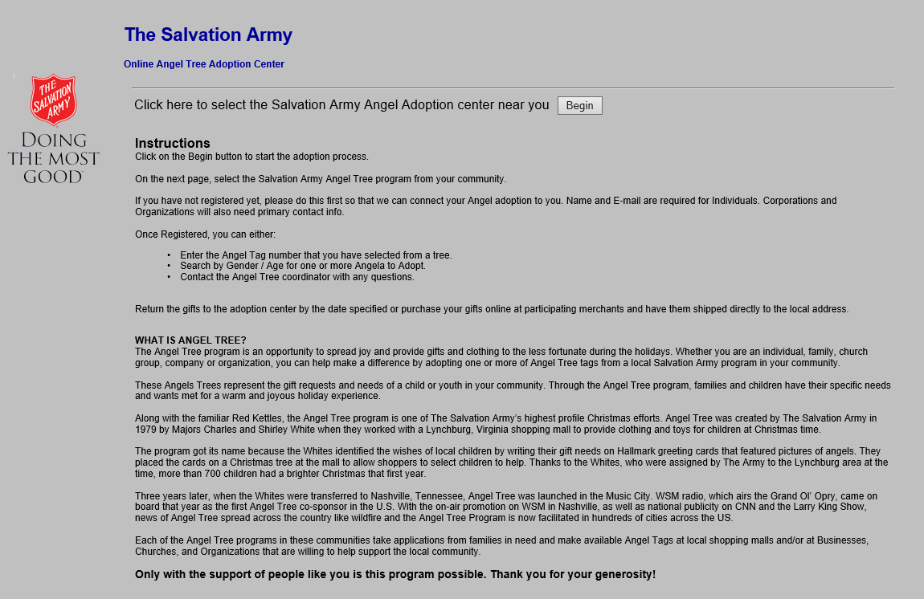

The next screen allows a potential sponsor to locate the Corps / Angle Tree program in their community.

* They can use the Corps Code (individual sites can publish this)
* They can use zip code to limit the results
* They can use an angel tag code
* They can login if already a sponsor to manage their angel adoption process
  + Select an angel or two
  + Notify the Angel Tree Coordinator by email that they have dropped off the gifts
  + Send tracking info if they are shopping online and sending directly to the warehouse

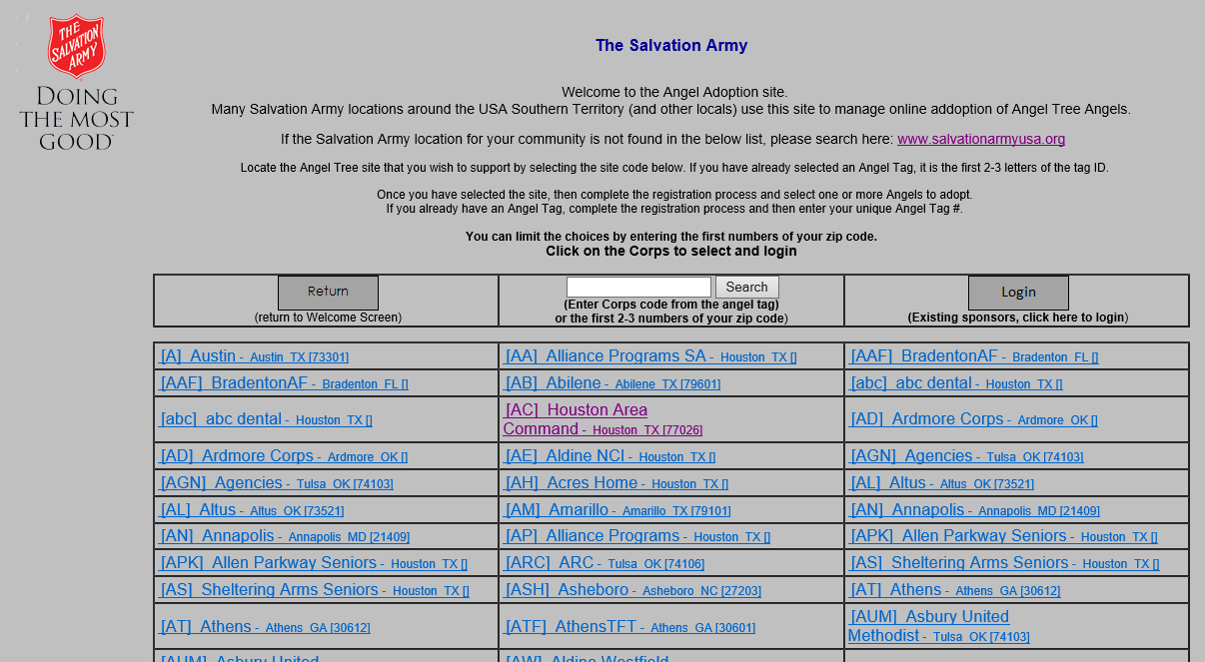

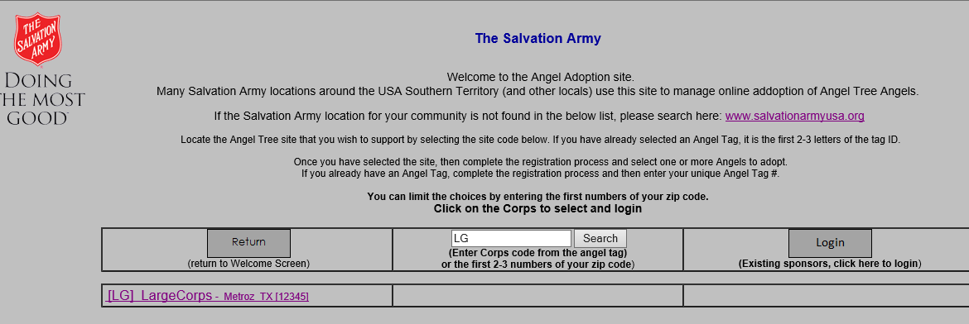

Click on LG to connect to that site and login

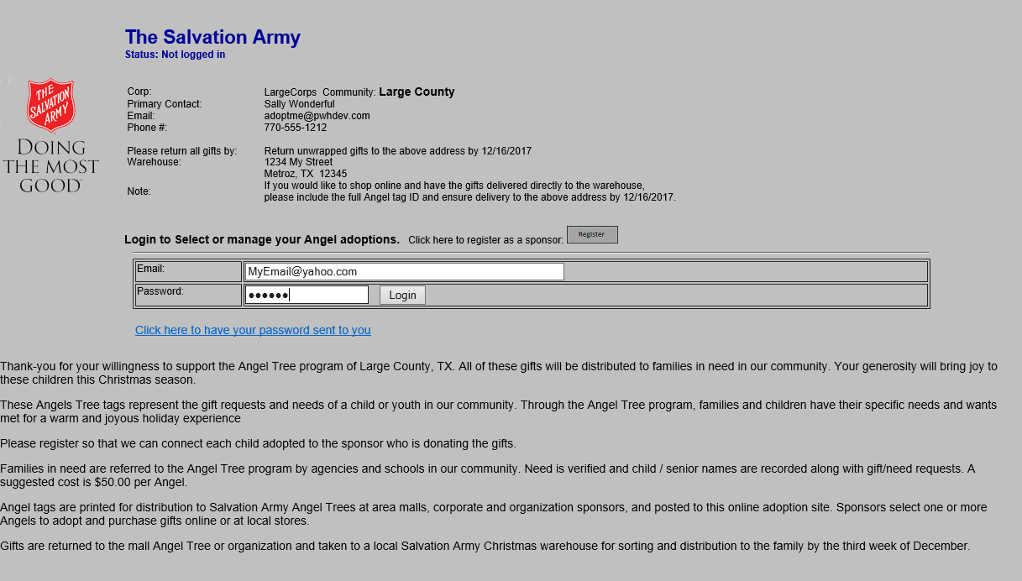

Or click to Register with this Angel Tree site:

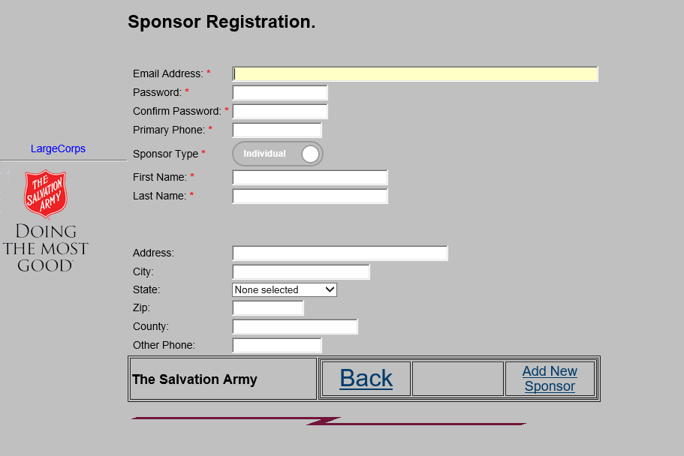

The next set of screens will allow the sponsor to manage their own information, select available angels, and do some emailing from the system to notify the designated Angel Tree Coordinator that events have happened.

I envision this could happen at a managed Angel Tree site in a mall where a wireless laptop / tablet or two were available for people to select a tag and then register before walking away

Or

Some instruction on the tag to tell folks how to self-register

Or

Corporate / organization sponsors can be setup in AngelWeb and have a number of angels assigned.

These can be printed and the site URL given to them to manage their own angels.

For example, here is what a sponsor login would look like with several angels selected:

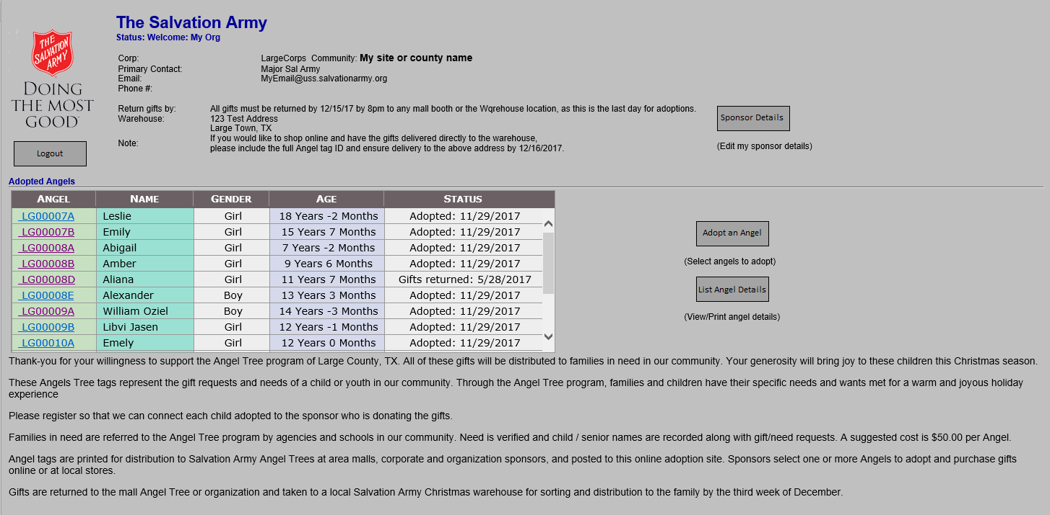

Clicking on any of the Angel links, you can see what would be printed on the tag and it allows the user to print or shop online for the gifts.

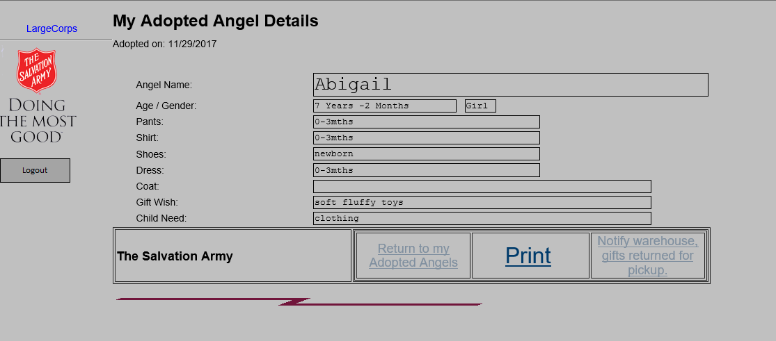

You can click on **List Angel Details** to get a full list:

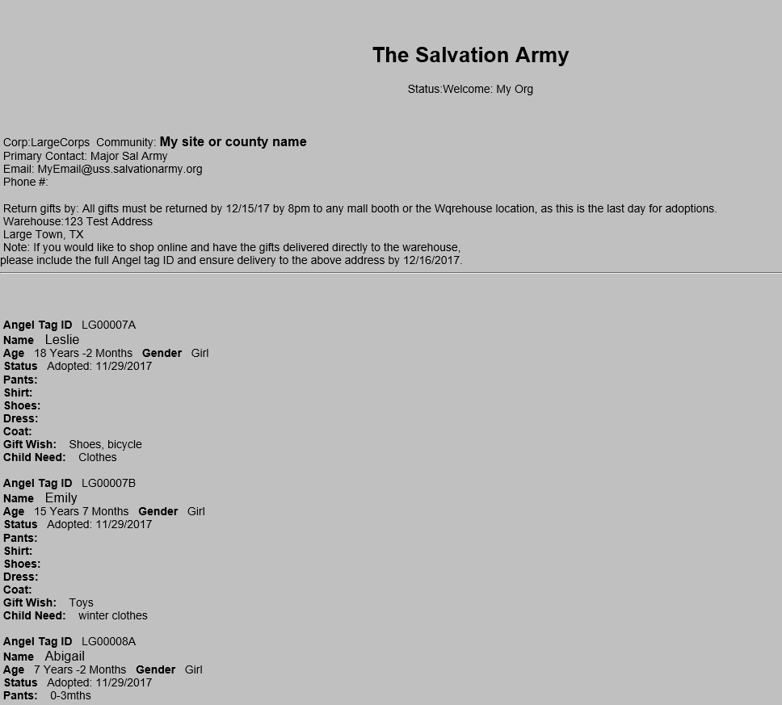

A Sponsor can select from a random list of 30 available Angels – with options to select an age range and/or gender – and adopt additional angels:

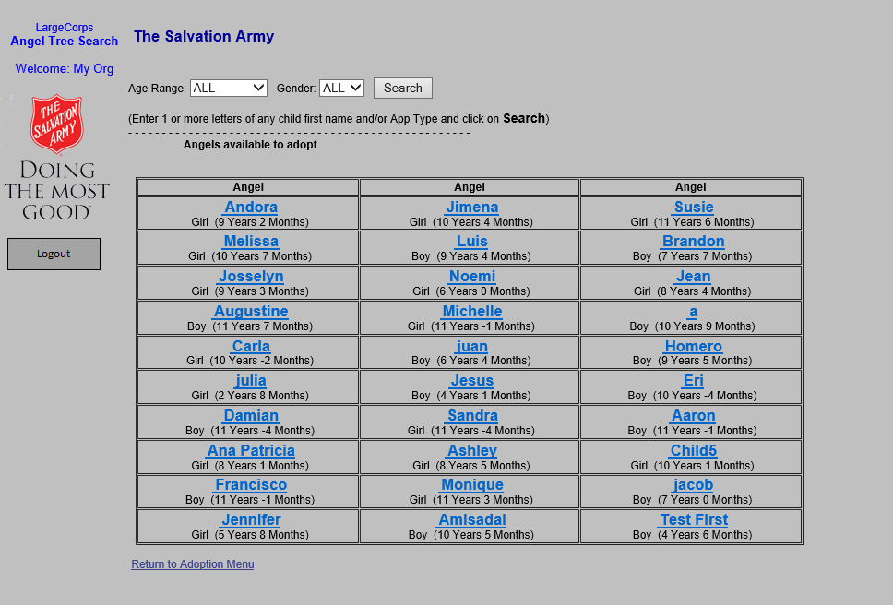

From Inside AngelWeb, there a set of screens to configure and manage this:

=========

Corps setup allows you to customize the text of the messages on your site’s screen that are public facing:

