AngelWeb
  - Managing Sponsors and Adoptions
From the main menu, select Adoption Sponsor Menu
Select Search Sponsors to work with Sponsor information.
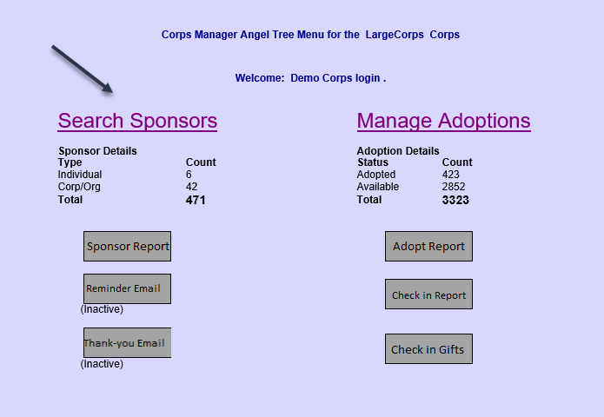
Search for and select a Sponsor
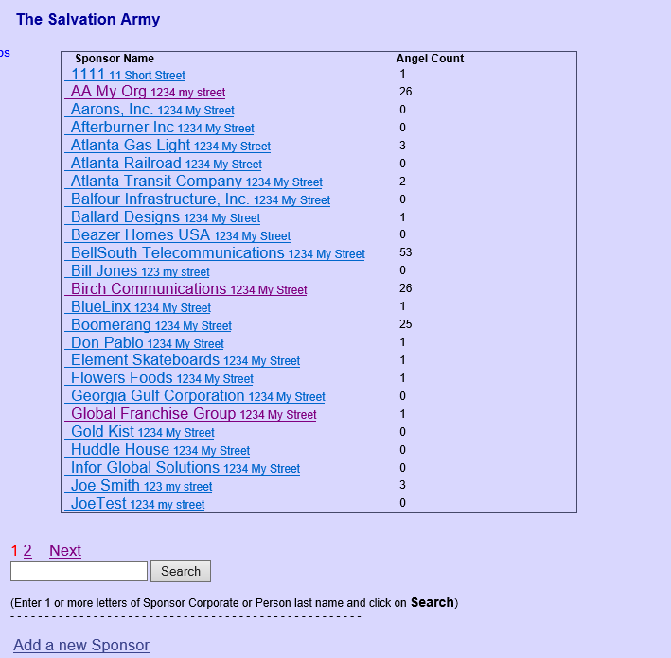
From the Sponsor screen, you can manage Sponsor Contact information, Look at Adopted Angel information, or add/remove more angels to this Sponsor
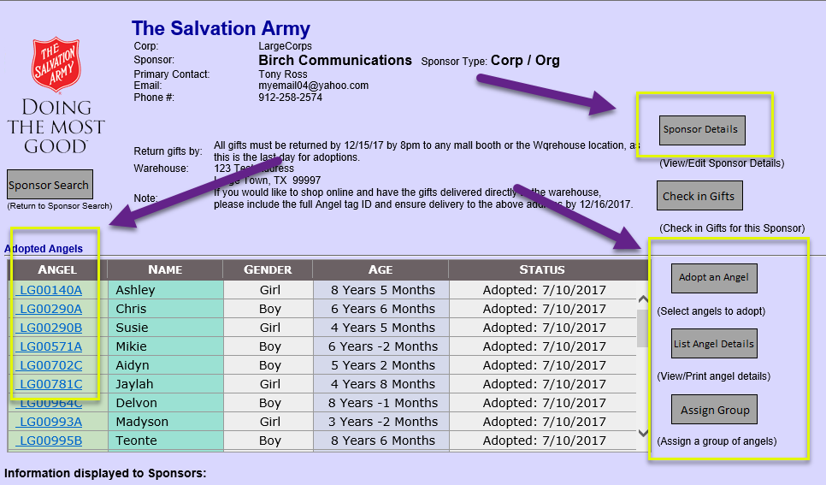

Manage Sponsor information
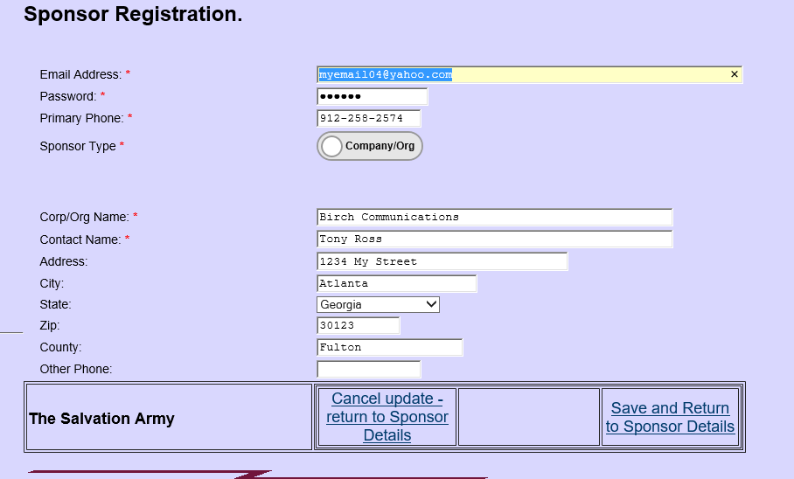

View details about an adopted Angel
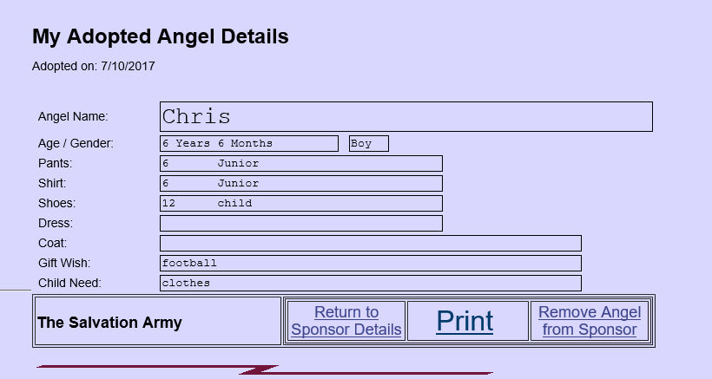

Adopting Angels:
Click on Adopt an Angel to select from a list of 30 available angels. You can search by Gender and Age range.
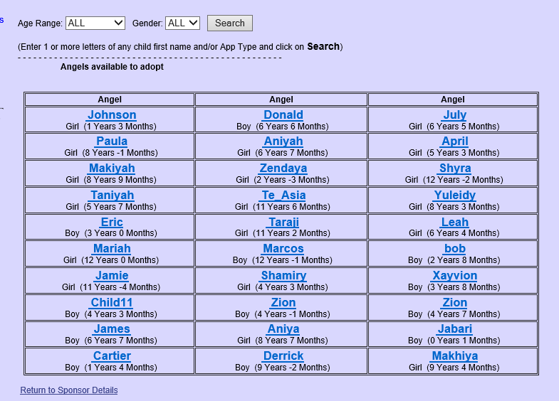
Click on an angel and confirm adoption to add to the Sponsor.

Click on Assign Group to add a batch of angels to the sponsor.
Select a number of Angels to assign to the Corporation / Organization
and Click on Assign
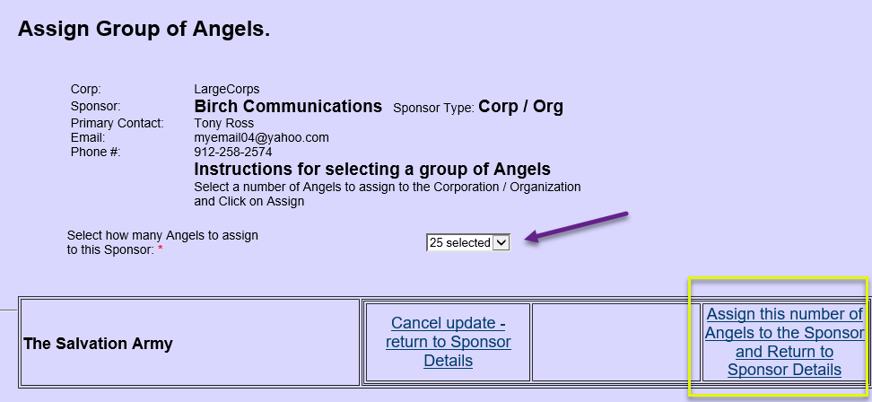

Click on List Angel Details to see gift requests for all angels assigned
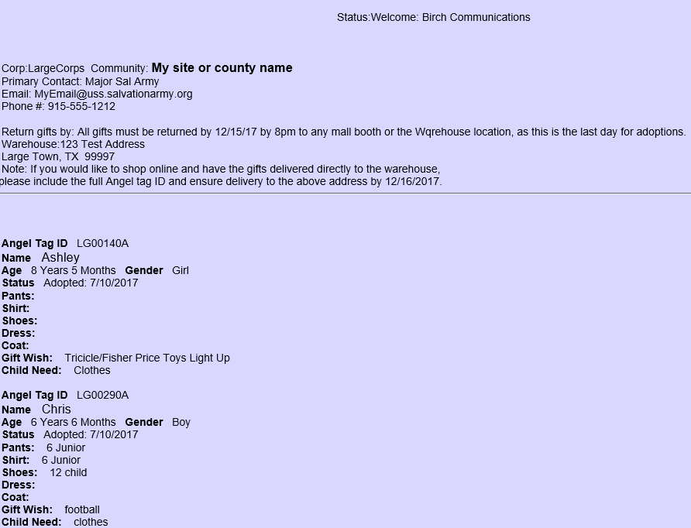

At the warehouse, click on Check in Gifts to mark the gift bags as they arrive
This screen opens to show only Angels that have not been checked in.
Click on a tag to check in that Angel.
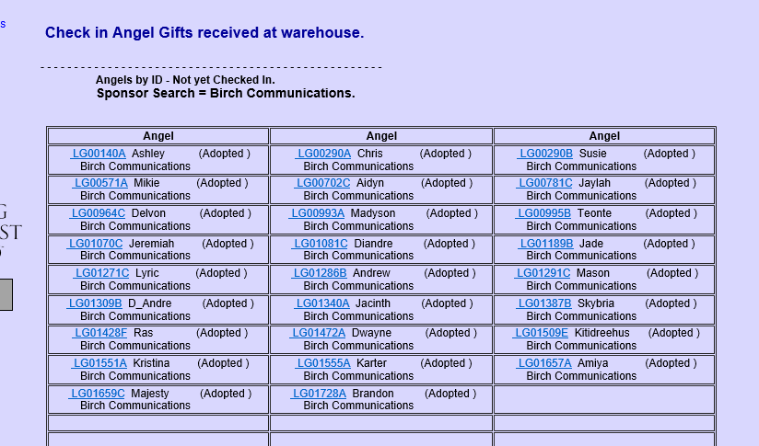

You can change the view by selecting All / Adopted for this sponsor
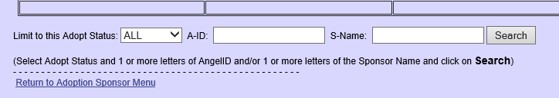

From the Sponsor menu, click on Manage Adoptions
You can search by a specific Angel ID or by status
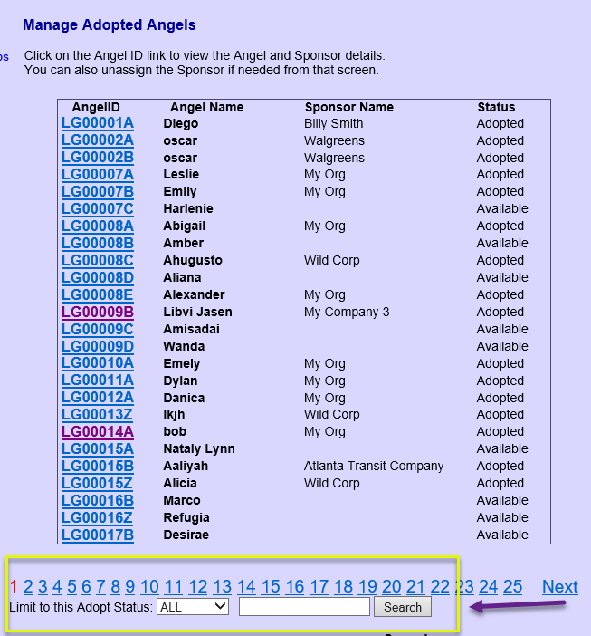

From the Sponsor menu,
- Generate Sponsor, Adoption, and Check-in Reports
- Send a Reminder Email
- Send a thank-you Email to the sponsors of checked in gifts
Sends a batch to those who have not been sent yet

